1. **Brief yourself, tell about your Self. Tell about your previous experience?**

-----------Name

---------Education

-----------Experience: I am totally having 3 years of experience in QA , Out of which 2 years automation & 1 year in manual testing . &currently working in TY as Software test Eng & previous company I was working with XYZ company.

In my previous organization I was in to Automation , my roles & responsibility are.

1. **Why are switching the company?**

I am changing the company, test Yantra is trying deploying me Here.

1. **What is your roles & responsibility?**
2. Whenever we get manual test case from the manual team, our team lead is going to allocate test case to us via JIRA/QC
3. When test case is allocated, we do execute test case manually to understand the business flow of the application. if test case is not clear talk to author/team lead & get the clarity, or else consider for automation
4. We also check whether test case is automatable or not?, if not automatable mark test in not automatable in JIRA
5. Involved in test scripts development
6. Before test scripts development, get the latest framework form the Git HUB
7. Involved in Test data creation
8. Involved in test POM class creation & adding elements in to repository if required elements are not available. Or else reuse the existing elements
9. Involved in **test data** creation
10. Involved in writing relative xpath for elements, & add those elements in to POM class

Using @findBy & FindBys annotation

1. Involved in **business/ workFlow** library creation
2. Involved in **generic library** creation if required
3. Involved in development of test script using framework components
4. Involved in review test scripts using pull Request / Review board tool
5. When we get new build in to testing environment , Jenkins automatically execute the test suite & send out an email to everybody
6. Whenever we get an execution report email from Jenkins. I do verify the report & check whether my test scripts are pass or fail.
7. If test is fail, involved in debugging the test scripts & find the root cause of the issue. if issue WRT product => will raise regression defect in JIRA or else fix the test scripts
8. Involved in framework development
9. Involved in creation of generic action for every element in GUI like select, mouseMove() , swucthToWindow() etc..
10. Involved on giving KT to team members
11. Involved configuration of suite execution in Jenkins
12. Involved in maintenance of test scripts in Git Location
13. Involved in Sprint Review * retrospect meetings
14. Involved in tracking automation defect in Jira

1. **Explain Automation Life cycle**

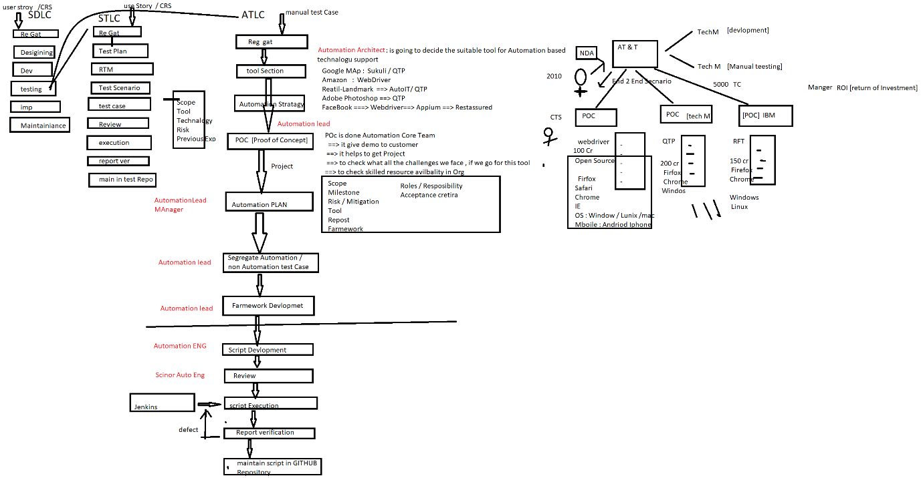

1. **What was not automatbale in your previous Project ?**

EG-1: In my previous project, there was a scenario, where createCutomer along with image of the Customer, in that scenario, I have automated Upload image but could not verify the Image Pixel

EG-2: In my previous project, there was a scenario, where create a Quotation & print the quota Document, in that scenario, I have automated click on print button, but

could not verify print response

EG 3: In my previous project, there was a scenario, where upload Product Demo Video.

That was not automatable

EG 4: in my Previous Project there was a Google Map Canvas Image, that’s was not automatable

EG 5: in my Previous Project there was standalone Popup, that’s was automatable

1. **Explain the Challenges you faced in automation?**
2. In my previous Project, I was automating one end-2 end test case which contains more than 20 steps, during the test scripts execution we faced synchronization issue. to overcome that issue we have provided wait generic methods
3. Hence Webdriver is an open source tool , which doesn’t have customer support , so to work latest technology is challenging
4. My manager told to introduce retry Listener, I googled it & fond solution
5. I have allocated database related test case that was challenging, I have introduced database utility
6. I have involved generic libraries creation that was challenging.
7. In my previous Framework , there was no advanced report , I have introduced Extent reports
8. In my previous Framework , there was no Automatic Screen Shot feature report , I have introduced ITestListener
9. In my previous project , I have allocated to automate file upload test case that was challenging robot class / autoit to automate that scenario
10. In my previous project , there was a scenario where I need execute multiple times by changing the data again & again that was challenging, I have introduced Random class in java to generate random data
11. Writing xpath of dynamic xpath element is challenging, I have used lots advance xpath function
12. When manual test case is not clear, automation in challenging.
13. When team member is not cooperative, automation is challenging. We have to intimate to immediate reporting manager.
14. Handle git confit is challenging.
15. Initial environment setup is challenging.

========================================================

1. **Explain few complicated scenarios which you automated in your previous Project & explain the Challenge**
2. **Explain one critical bug which you got via automation**
3. **What is your daily Activity.**

When Ever I reach Office to Check Email

Email => WRT 🡺 Review

Email => WRT 🡺 test Script Allocation

Email => WRT 🡺 Meeting

Email => WRT 🡺 JIRA (retest the defect)

Email=> WRT 🡺 JENKINS 🡺 verify the report

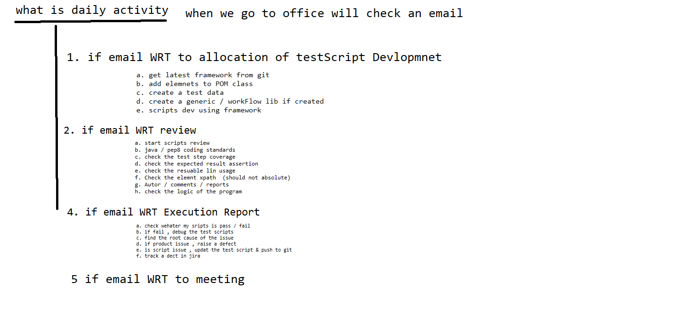

10. When batch execution is done via Jenkins, all test scripts got fails what might be the issue ?

1. Common test data issue, url is wrong or username/password is wrong
2. Browser compatibility issue, automatically browser getting updated
3. Login GIU(html) is changed.
4. Bug in login change
5. Application server is down
6. Build is broken, due wrong file push in to GitHub

EG: login method name is modified & by mistake pushed in to GitHub.

1. **What is duration of the Project?**
2. **What is the sprint duration in your previous project?**
3. **How many build you get in one sprint?**
4. **How many test case you had in your previous project?**
5. **Which processes you fallowed?**
6. **How many test case used to get for automation in every sprint / release?**
7. **How many test case you automated /day/month/year/ in entire project?**
8. **What is your team size?**
9. **I will give 100 test case, what is your estimation?**
10. **How long automation batch execution take place?**
11. **How may defect you found via automation in your previous project?**
12. **Percentage of manual & automation in your previous project?**

**3000 tc 🡺**

* **10 % not automatable (300)**
* **90 % automatable (2700)**

**🡺5% Smoke test Case (150)**

**🡺85% regression test case (2550)**

1. **How may smoke test u had in your previous Project**

120 test case / 3000

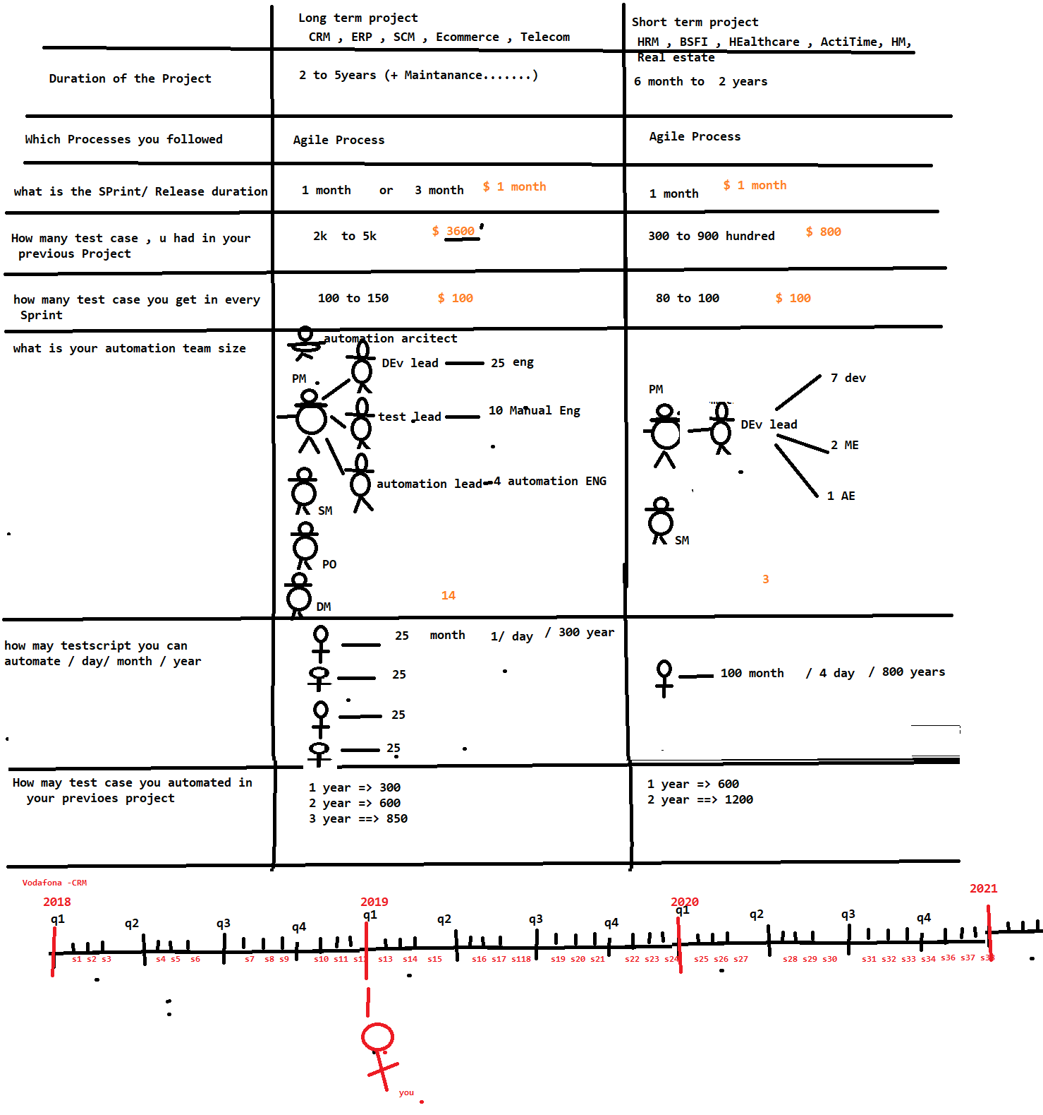

**400 /year**

**4 year**

**1 year**

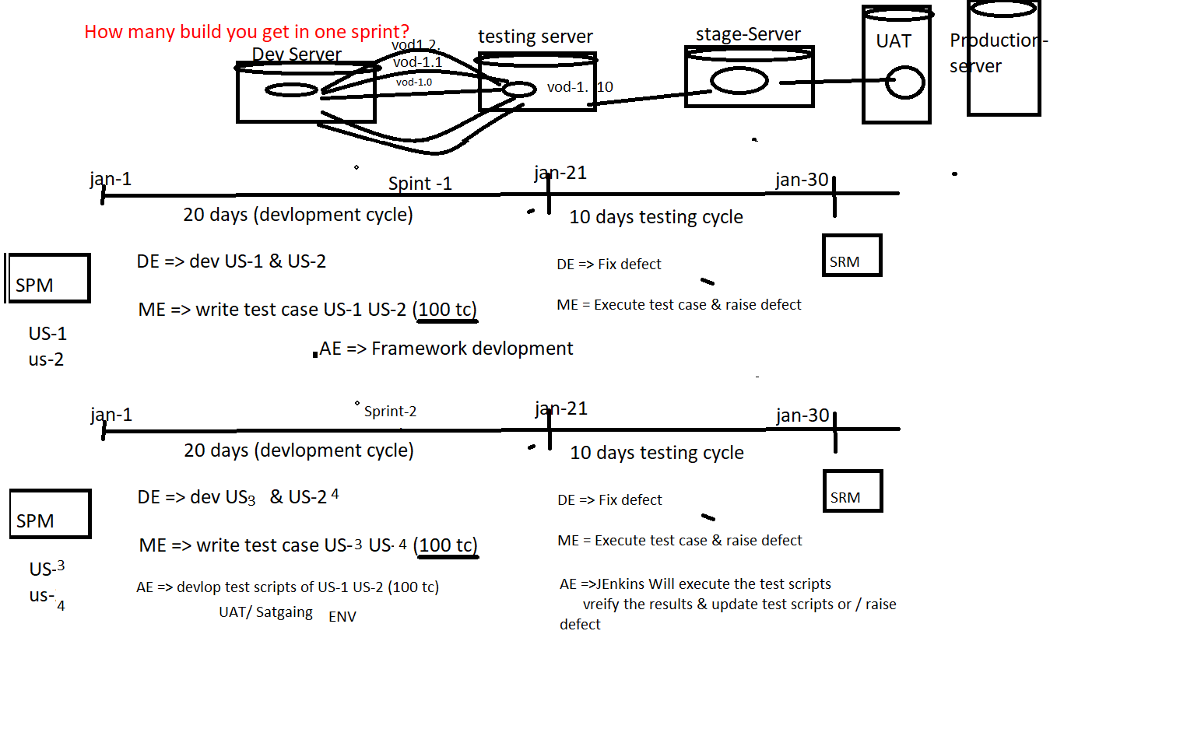

Feb-21

Feb-1

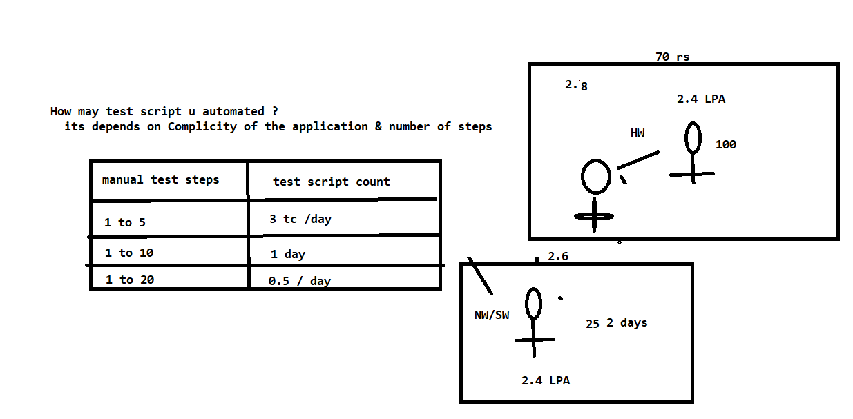

**What is your automation Estimation for 100 manual test case ?**

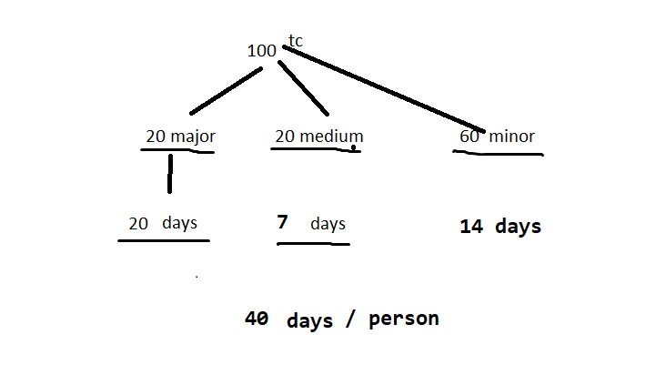

**How long automation batch execution take place ?**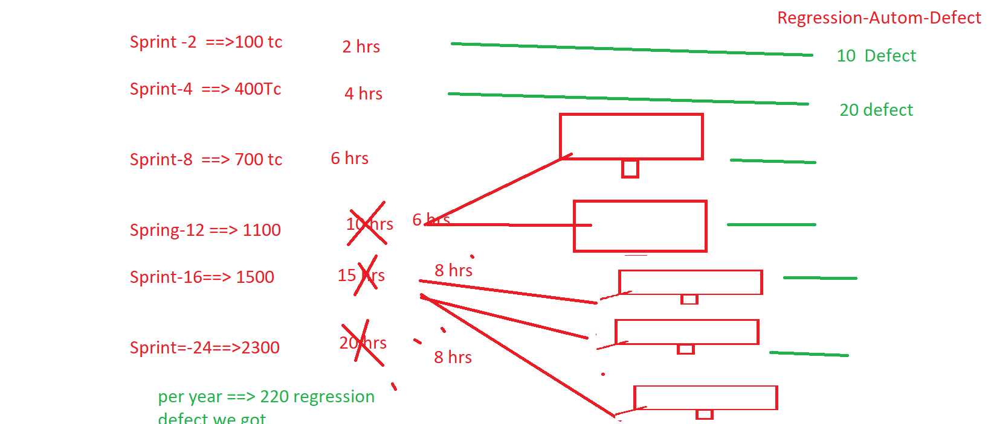

How may defect you found via automation in your previous project ?

